**PROJECT: Handling User Authentication .**

**Developer Name:** Nellore Sri Lavanya

This document contains contents for:

* Project Description
* Flow of the Application
* Core concepts used in project
* Conclusions.

**1.Project Description:**

* Set up a standalone project to do unit testing of the user authentication class which is used in the main web application.
* The objective is to create a JUnit class that will test all aspects of the authentication class.

**2.Application Flow:**

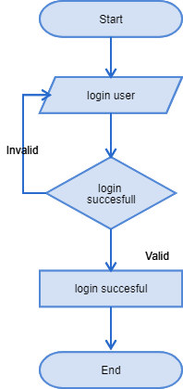

**3.Core concepts used in project:**

● Eclipse as the IDE  
● Apache Tomcat as the web server  
● Junit 5

**Conclusion:**

* This project is designed for Handling User Authentication